CS-000 Documentation Standards, Template & Revision Process
Doc ID | CS-000
Title | Documentation Standards, Template & Revision Process
Revision | C
Status | Draft, pending Lead signature
Effective date | 2026-08-28
Supersedes | Ad-hoc SN5 documentation practice

Approvals
Role | Name | Date
Author | Simon Starbuck (drafted with Claude, SN6 Resources) | 2026-07-12
Reviewer | simon (reviewer agent)
Approver (Composites Lead)

Revision history
Rev | Date | Author | Description of change
A | 2026-07-12 | Claude | Initial issue
B | 2026-07-28 | Claude | Language pass: fewer em dashes for rhythm variety, no content change.
C | 2026-08-28 | Claude | Engineering pass, requested by Simon Starbuck. §4 defines the normative verbs (shall/should/may) the whole series now reads by, and states that numbered procedure steps are requirements. §7.1 records where figures live and how they are rebuilt, because the series now carries drawn figures. New Figure 1, the status lifecycle.

1. Purpose
We built good stuff in SN5 and barely wrote any of it down properly: not one doc had a revision number, changelog, or approver, and "what stack did the seat use last year?" was answerable only by whoever happened to remember (PP-09). This doc is how we name, structure, revise, and approve our documents so the knowledge outlives whoever wrote it. On a student team, turnover isn't a risk, it's a schedule.

2. Scope
All controlled composites documents: CS-XXX standards, work orders (WO-SNx-###), and formal deliverables (test reports, RCA docs). It does not control meeting notes, Slack threads, or scratch R&D notes, but any conclusion from those that the team relies on must graduate into a controlled doc.

3. References
Ref | Document | Where
R1 | SN5 Pain Points & Improvements, PP-09 | 01 Pain Points and Improvements/
R2 | CS-Template | 02 CS Standards/template/CS-Template.md (+ .docx)
R3 | CS-013 Work Orders & Part Traceability | CS-013

4. Definitions
- Controlled document: a document with a Doc ID, revision letter, and named approver; the team treats its current released revision as the way work is done.
- CS-XXX: a Composites Standard, numbered CS-000 through CS-999. The number never changes once assigned, even if the title is edited.
- Revision: letters, starting at A. Any change to procedure content bumps the revision; typo fixes may be batched into the next content revision.
- Status: Draft, pending Lead signature (written and reviewed but unsigned: usable as guidance, not yet the rule), Released (current practice; approver row signed), Under Revision (follow it, but changes are coming), Retired (kept for history; do not follow, its header must name the replacement). A doc whose Approver row is blank is never Released, no exceptions. The header must say so itself, because members read headers, not the INDEX footnotes.
- Normative verbs: every standard in this series uses them one way. Shall is a requirement: deviating from it takes a work-order revision or a lead's logged override. Should is a recommendation: the stated way is the default, and departing from it needs a reason you could say out loud at the Monday meeting, not paperwork. May marks an allowed option. A numbered step in any §7 procedure is a requirement even without the word "shall"; imperative mood carries the same force.
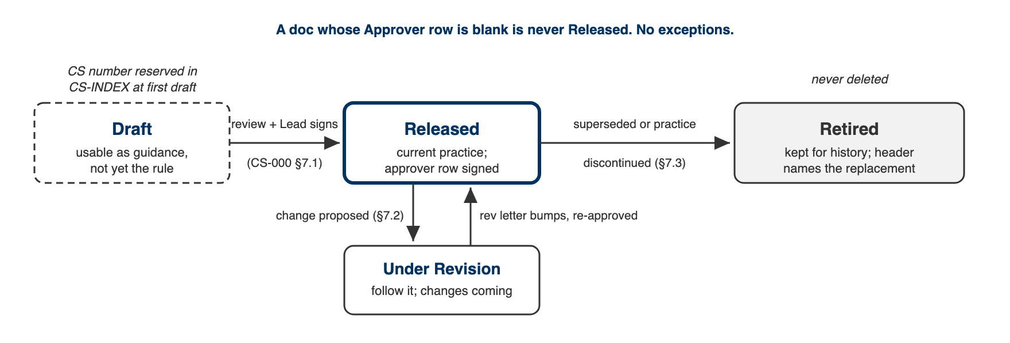
Figure 1. The status lifecycle. A document enters CS-INDEX at first draft and never leaves; Retired is an end state, deletion is not one.

5. Equipment & Materials
None; this is a process standard. Documents live in the team Drive under Composites > Standards (source + PDF/docx), and the master list is CS-INDEX.

6. Safety
No physical hazards; this is a process standard. (The section exists because every CS doc must carry one: CS-Template §6.)

7. Procedure

7.1 Creating a new standard
- Check CS-INDEX for an existing standard covering the topic; extend rather than duplicate.
- Copy CS-Template; take the next free CS number from CS-INDEX and add a row there with Status = Draft immediately (this reserves the number).
- Write the draft. Every quantitative claim gets a source: a TDS/SDS in 04 Datasheets/ (add it and its INDEX row if missing), a test report, or a recorded team measurement (work order ID). "We've always done it this way" is not a source; if that's all there is, say so explicitly in the text.
- Draw a figure where one carries the geometry better than prose: keep-out zones, stack-ups, plumbing, anything dimensioned. Figures are source-controlled as SVG in 02 CS Standards/src/figures/, rendered to PNG by tools/render_figures.mjs, and referenced from the markdown by the PNG name. Every distinction in a figure must survive a grayscale print (line weight, hatching, solid against hollow); Berkeley blue and gold are enhancement only, same rule as the shop travelers.
- Get one reviewer who did NOT write the draft to walk the procedure mentally (or physically, for shop procedures) and comment.
- The Composites Lead approves: name + date in the approval table, Status → Released, CS-INDEX updated.

7.2 Revising a standard
- Anyone may propose a revision. The trigger that matters most is an incident: if a part or mold is lost to a process failure, the relevant standard gets reviewed within two weeks while memory is fresh, and either revised or explicitly re-affirmed in its changelog.
- Set Status → Under Revision in CS-INDEX so users know changes are coming.
- Make the change, add a revision-history row (what changed and why, one line each), bump the revision letter.
- Same review + approval as 7.1. Announce released revisions in the weekly summary message.

7.3 Retiring a standard
- Set Status → Retired in the doc header and CS-INDEX; state the replacement (a CS number, or "practice discontinued").
- Never delete the file. Retired docs are the team's institutional memory (the Duratec story is worth more retired than deleted).

7.4 Annual handoff review
- Each summer, the incoming lead skims every Released standard with the outgoing lead (budget ~2 hours total) and marks each: still right / needs revision / retire.
- Findings go into CS-INDEX notes; revisions get scheduled, not just wished for.
⚠ CAUTION: A standard nobody can find is a standard that doesn't exist. CS-INDEX is the single place that lists every document, its revision, and its status: keep it current at the moment of change, not "later".

8. Quality checks / acceptance criteria
Check | Target | Method | Record where
Every released CS doc has ID, revision, approver, changelog | 100% | Skim headers | CS-INDEX
Quantitative claims cite a source | Every number traceable | Reviewer walk-through (7.1 step 5) | Review comment in doc
Post-incident review | Within 2 weeks of losing a part/mold | Lead checks at Monday meeting | Changelog row
Annual handoff review done | Before fall recruiting | Incoming lead | CS-INDEX notes

9. Records
CS-INDEX is the record. Work orders (CS-013) record per-part execution; this standard records how the documents themselves are kept honest.

Appendix: why this exists
SN5's two documentation tiers were formal deliverables (author + date, no versioning) and stub templates (often empty). Both rotted silently: the Mold Sealer Alternatives study (Oct 2025) recommended S120/water-based sealers, was overtaken by the XCR decision (Feb–Apr 2026), and nothing marked it superseded. A new member reading the Drive in July 2026 could not tell which document described current practice. Status fields and CS-INDEX exist to make "which doc is true" a lookup instead of an archaeology project.

